
O RADIO
REPUBLIK
INDONESIA
Jakarta, 1 April 2026
Dear Colleagues,
32nd Intellectual Property & Legal Committee 22nd - 23th July 2026
Greetings from Jakarta, Indonesia.
It is our distinct honour and privilege to invite you to the 32nd meeting of Intellectual Property & Legal Committee of the Asia-Pacific Broadcasting Union (ABU) which will be hosted by Radio Republik Indonesia (RRI) in Jakarta, Indonesia on 22nd — 23th July 2026. Kindly send in your nominations to ABU Officers at the earliest.

Looking forward to your participation to make this occasion another successful event.
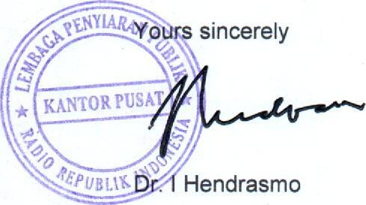
President Director of Radio Republik Indonesia - RRI
CC. Dr. Seemantani Sharma - Legal Manager , Asia-Pacific Broadcasting Union
RADIO REPUBLIK INDONESIA KANTOR PUSAT
Jl. Medan Merdeka Barat No. 4-5, Jakarta Pusat
Nomot- Telp./Fax : (021) 34835183 Email : set.dirut@rri.go.id

